# Phase 4: Process Automation (Admin) – *Library Rental Tracking*

This phase focuses on automating library rental management processes in Salesforce to enhance efficiency, ensure compliance, and reduce manual errors.

## Validation Rules

Implemented validation rules to enforce data quality and accuracy.  
**Examples:**

* Prevent issuing a book if no active student/member record is linked.
* Ensure due dates are always after the issue date.
* Disallow return entry without a valid issued record.

**Process Flow:** Setup → Object Manager → [Object] → Validation Rules → New

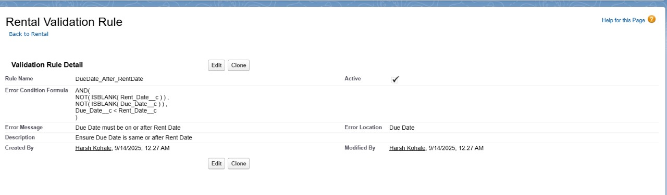

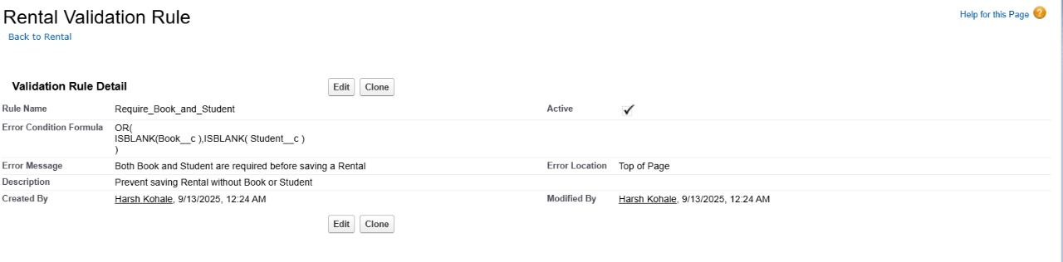

## Workflow Rules

Created workflow rules to automate standard actions based on criteria.  
**Examples:**

* Auto-send a reminder email/SMS to students when the return due date is near.
* Notify librarian when a book is overdue by more than 7 days.

**Process Flow:** Setup → Workflow Rules → New Rule

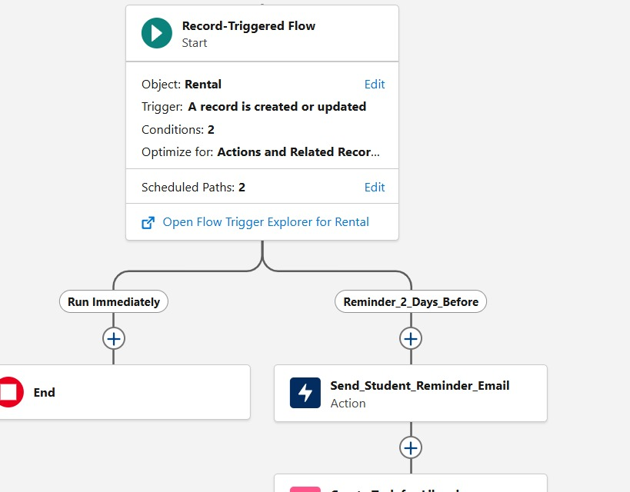

## Process Builder

Designed processes for multi-step automation where workflow rules were insufficient.  
**Examples:**

* Auto-create a fine record if a book is returned late.
* Update book status to *“Available”* automatically when returned.

**Process Flow:** Setup → Process Builder → New

## Approval Process

Set up approval processes for special library requests.  
**Examples:**

* Approval for book renewal requests routed to Librarian.
* Approval for high-value or restricted books routed to Head Librarian.

**Process Flow:** Setup → Approval Processes → New Approval Process

## Flow Builder

Implemented flows for advanced automation:

* **Screen Flows:** Guide librarians through book issue/return entry step by step.
* **Record-Triggered Flows:** Auto-generate fines and update book stock when a return is logged.
* **Scheduled Flows:** Weekly overdue report sent to librarian and guardians.
* **Auto-Launched Flows:** Automatically enroll new students into *default borrower list* when their student record is created.

**Process Flow:** Setup → Flow Builder → New Flow

## Email Alerts

Configured email alerts for communication and reminders.  
**Examples:**

* Confirmation email sent to students upon successful book issue.
* Overdue reminders sent to both students and guardians.

**Process Flow:** Setup → Email Alerts → New

## Field Updates

Automated field updates to maintain record accuracy.  
**Examples:**

* Update *Book Status* to “Issued” when linked with a rental record.
* Update *Book Status* to “Overdue” if return date passes without return.

**Process Flow:** Setup → Workflow Actions → Field Update

## Tasks

Automated task creation for staff.  
**Examples:**

* Create follow-up tasks for librarian when fines are pending.
* Assign return-check tasks for assistants when a book’s due date approaches.

**Process Flow:** Setup → Workflow Actions → New Task

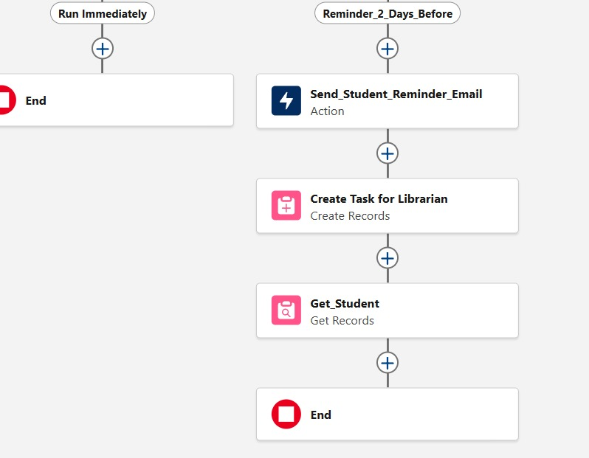

## Custom Notifications

Enabled instant in-app and mobile push notifications.  
**Examples:**

* Notify librarian immediately when a book is overdue.
* Alert students when their renewal request is approved/rejected.

**Process Flow:** Setup → Notification Builder → New Custom Notification

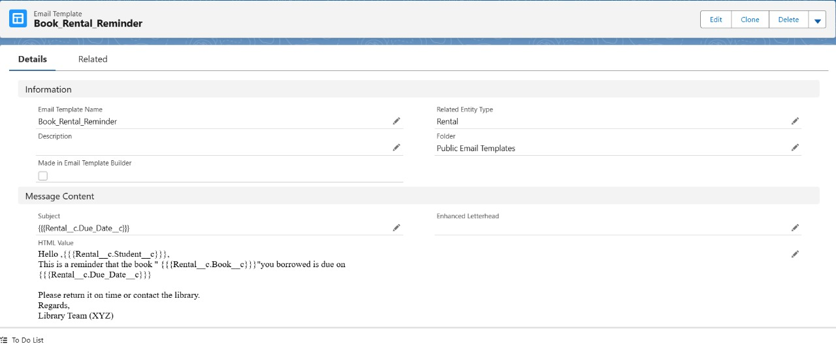

## Outcomes of Phase 4

This phase streamlined **library rental tracking** by eliminating manual work such as tracking due dates, fines, and renewals. Automation ensured timely reminders, accurate book availability, and better communication between students, librarians, and guardians. The institution now benefits from **higher efficiency, fewer missed deadlines, reduced losses, and improved user experience.**